The PhD student (2022)

Number | Name | Grade | E-mail
1 | 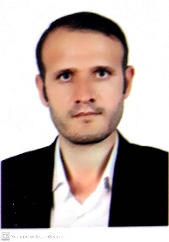  Alireza Sharifi | PhD Student | alireza.hse@gmail.com
2 | 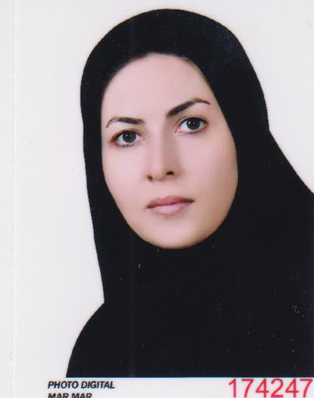  Maryam Afravi | PhD Student | maryamafravi@gmail.com
3 | 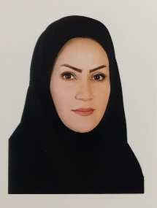  Elham Rahmanzadeh | PhD Student | e.rahmanzadeh@gmail.com

